W228A/1204C, W228B/1204C



DUBLIN INSTITUTE OF TECHNOLOGY
_____________

DT228A/1 MSc in Computing
DT228B/1 MSc in Computing
______________

WINTER EXAMINATIONS 2016/2017
______________

Probability and Statistical Inference [Math9100]

Ms. deirdre Lawless
Dr. Deirdre Lillis
Mr. Conor sayles

[TBA Duration 2 hours]

Two Hours

Instructions to candidates

Answer question one and one other question.

All questions carry equal marks.

Description of Statistical Research Inquiry used in All Questions
An organisation, which manufactures pharmaceuticals, has commissioned a research team to conduct a survey to investigate the level of satisfaction among its employees with the organisational culture. The organisation currently employees 20,000 people in eight different countries in three different continents. The majority of employees are employed in the manufacturing plants working on the production line. The majority of staff in the organisation are aged between 20 and 35.
A 5% cut-off level of statistical significance has been set for the project.
The research team decided to distribute the survey to employees in the headquarters of the organisation in each city in which the organisation has a presence worldwide. Finance, marketing, human resources and research and development processes are managed in these centres, employing 1,500 people, the majority are aged between 25 and 35. Five hundred and thirty six employees responded.
The research team conducting the survey also designed it. The survey consisted of ten Likert scale questions which asked employees to rate their agreement with the question topic and their perception of the importance of the question topic. The questions were designed by this research team based on research they conducted into the concept of employee satisfaction with organisational culture. This is the first time that the survey has been deployed. By aggregating the answers to these questions, the researcher has derived a total satisfaction score. In addition, the survey also collected respondents’ age and their length of service with the company (in years). The section of the survey relevant for this research is shown in Figure 1 on the next page. The variables of interest in the resulting dataset are shown in the table below.

Name | Label | Values | Type
age | Employee Age | 1 under 20; 2 21-30; 3 31-40; 4 41-50; 5 over 50 | Ordinal
Zservice | Standardised score of No. of years working in organisation |  | Scale
Ztotsatis | Standardised score of composite score representing an employee’s level of satisfaction |  | Scale

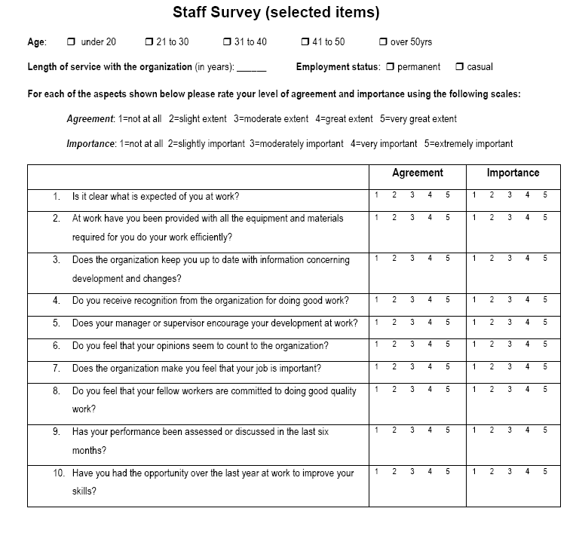
Figure 1: Section of Staff Survey

1. | (a) | The research team conducted an initial exploration of the data to identify its suitability for use in the proposed investigation. The team was particularly concerned with the following:  - Representativeness  - Outliers  - Central tendency and variability  - Clearly explain why each of the above can be a concern for a statistical inquiry.  (12 marks)
- Discuss what the research team can conclude about this dataset about each of these concerns for each of the variables of interest. Consider the description of the research inquiry provided and the descriptive statistics and graphs included in Appendix A.
(12 marks)

- Make recommendations which, in your opinion, would be most useful to address the issues of concern for this dataset.
(8 marks)

1. | (b) | The research team wishes to investigate the relationship/differences between:  - Age and Total Satisfaction Score  - Length of Service and Total Satisfaction Score.  Based on your answers to part (a) and using the output of the tests in Appendix A for each pair of variables:  - Identify the test you feel is most appropriate to investigate the relationship/difference. Justify your answer.  (2 x 3 marks)
- Interpret the output of the test you have chosen and explain what can be concluded about the relationship/difference between the variables in the context of the proposed research.
(2 x 6 marks)

2. | Having addressed the issues of concern identified in Q1, the research team has decided to further explore the relationship between the standardised total satisfaction score and the standardised length of service and age category. The team is interested in three different age groups under 30; 30 to 40 and over 40. To explore this age category has been recoded into two variables thirtytoforty (1 if between 31 and 40, 0 otherwise) and overforty (1 if over forty and 0 otherwise). A multiple linear regression model has been created using these variables and standardised length of service as the independent variables and standardised total satisfaction score as the dependent variable.
2. | (a) | Explain what linear regression could allow the research team to achieve in terms of their research. In your answer you should clearly explain the following:  - What regression will allow the researcher to do;  - What prediction means in this context;  - The type of variable used to include the age categories of interest in the model and why this type of variable is needed.  (12 marks)
 | (b) | For the model created:  - Assess its fit and usefulness.  (12 marks)  - Explain how to interpret the model created for staff aged under 30, 30 to 40 and over 40 regardless of the significance of the model.  (16 marks)  In your answers you should state the regression equation, clearly explain any concepts or statistics to which you refer. Illustrate your answers by referring to the statistics included in Appendix B.
 | (c) | If you were asked to choose between exploratory factor analysis and principal component analysis to create a composite score of total satisfaction from their answers to q1a to q10a, which technique would you recommend and why?  (10 marks)

3. |  | Rather than use an aggregate score from the relevant questions, as currently exists in the dataset, the research team want to use Exploratory Factor Analysis to derive the composite score for total satisfaction from respondents’ agreement with questions 1 to 5.  Explain what this approach will allow the research team to achieve and discuss the suitability of the dataset for use with this approach.  In your answer you should clearly explain any concepts or statistics to which you. Illustrate your answers by referring to the statistics included in Appendix C.  (20 marks)
 | (b) | Discuss the outcomes of the application of exploratory factor analysis and assess its effectiveness for the purposes of the research team.  In your answer you should clearly explain any concepts or statistics to which you refer. Illustrate your answers by referring to the statistics included in Appendix C.  (18 marks)
 | (c) | Suppose the first factor extracted during exploratory factor analysis has been saved to the dataset as efatotsatis (EFA generated total satisfaction score) and that the research team wish to build a regression model using standardised length of service and age category as predictors of this new variable.  Briefly discuss the main assumptions that must be met for the independent and dependent variables when undertaking a linear regression.  Illustrate your answer by reference to the statistics provided for the variables of interest in Appendix A, Appendix B and Appendix C.  (12 marks)

Descriptives: Length of Service and Total Satisfaction
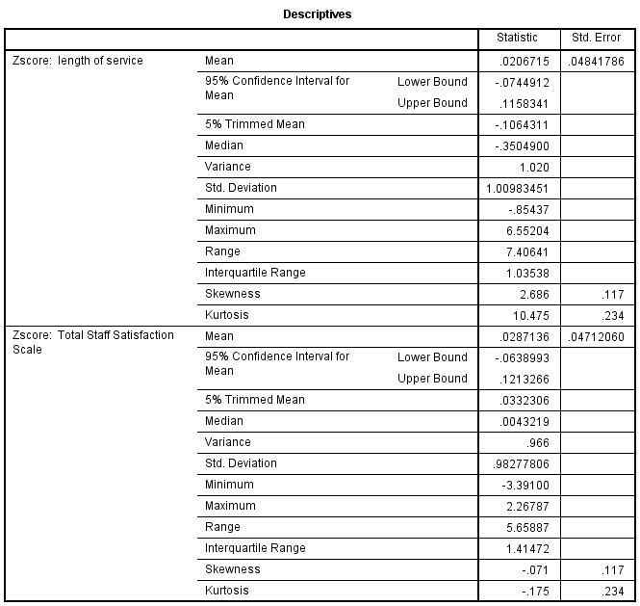 | 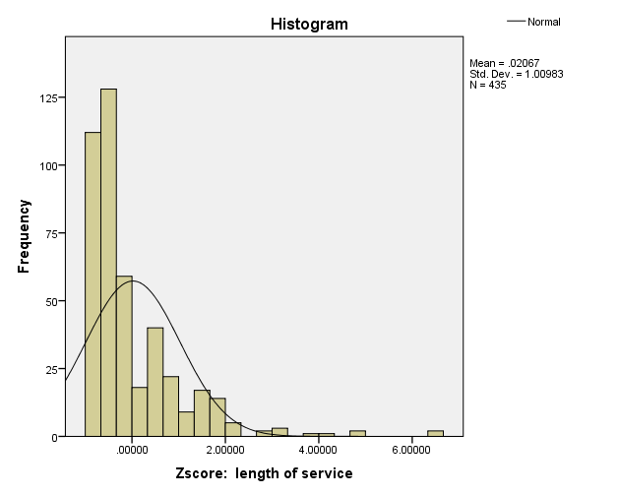  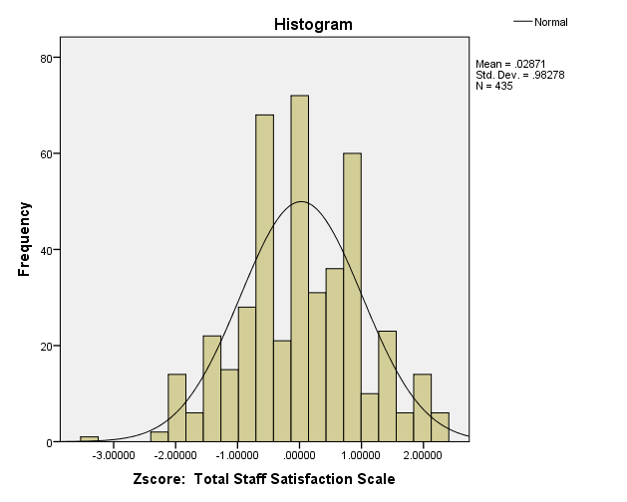

Descriptives: Length of Service and Total Satisfaction
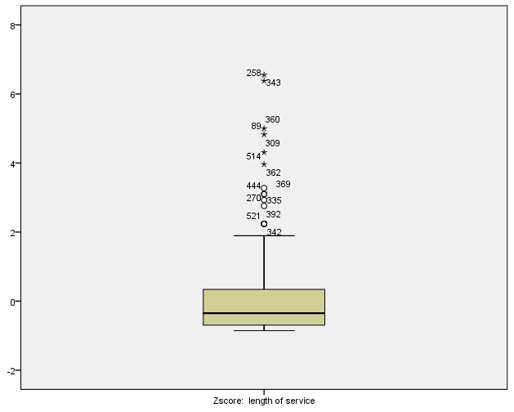 | 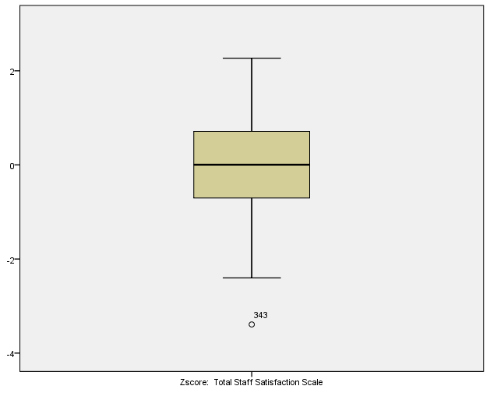
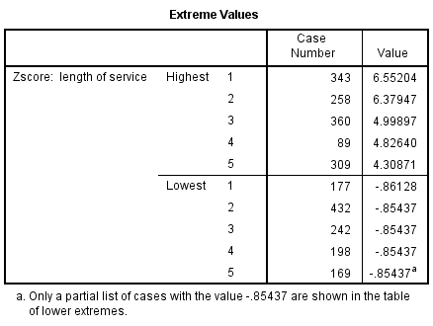 | 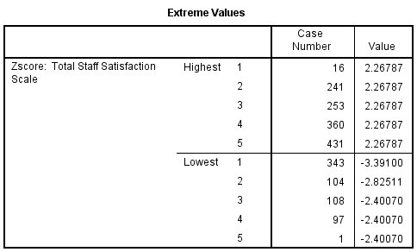

Descriptives: Age Category
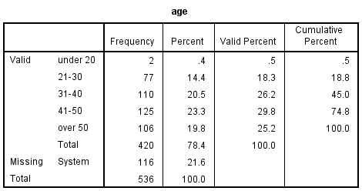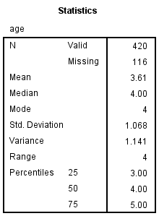 | 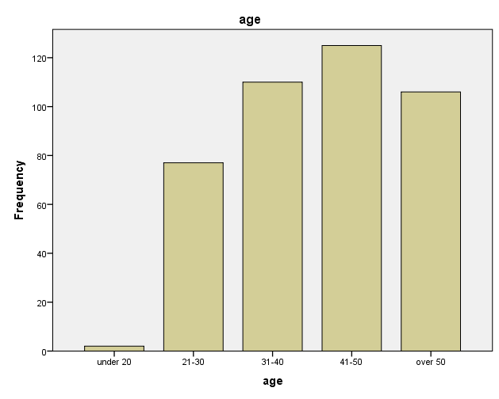

Tests: Age and Total Satisfaction | 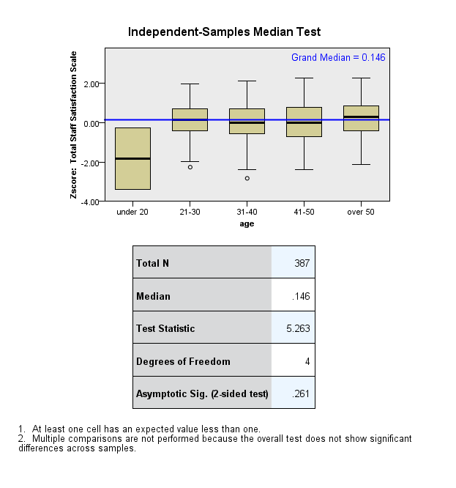
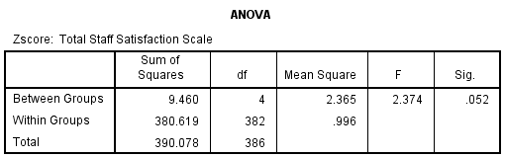
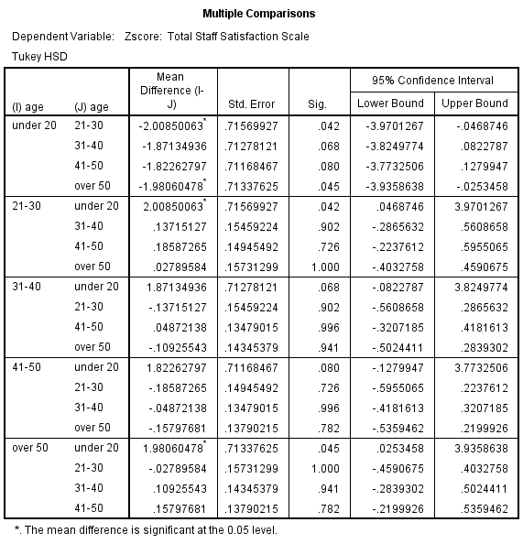

Test: Length of Service and Total Satistfaction
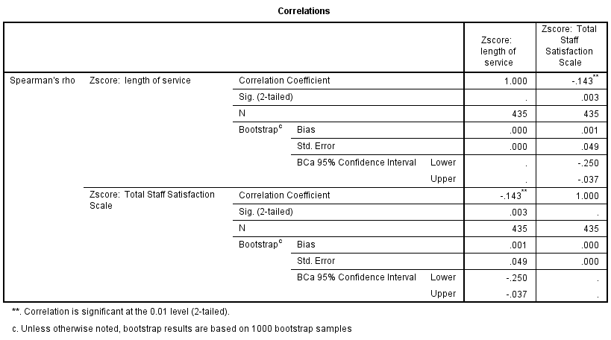
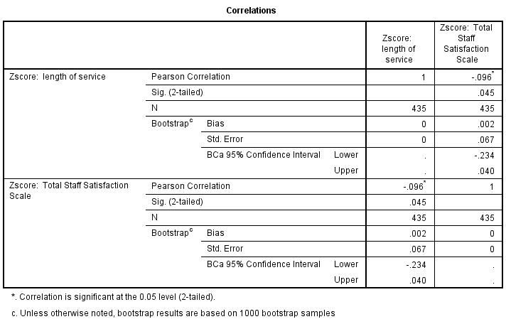

Independent t-tests  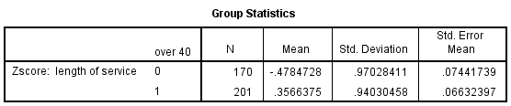 |  | 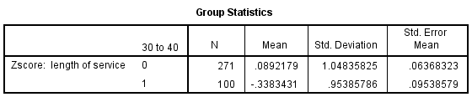
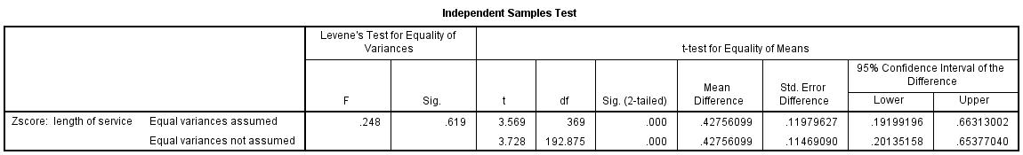
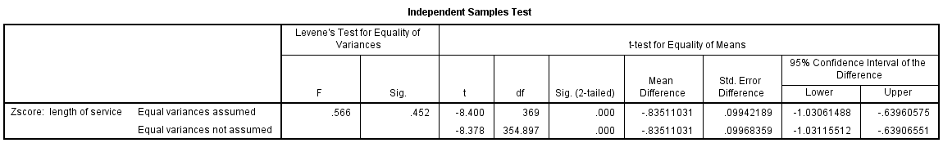
Multiple Linear Regression
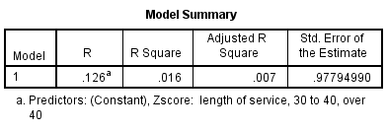
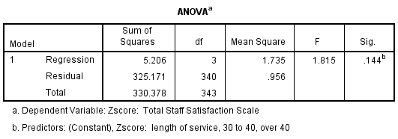 | 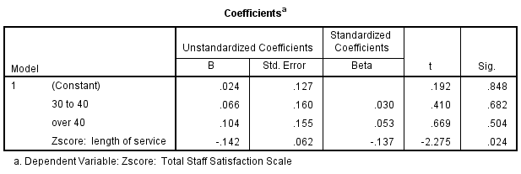

Exploratory Factor Analysis
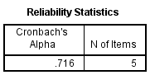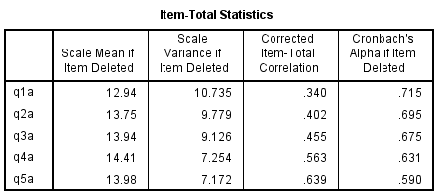 | 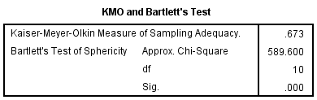
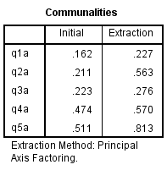 | 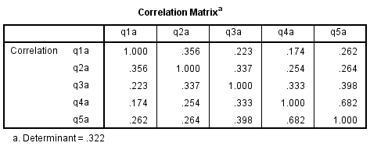
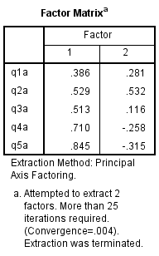 | 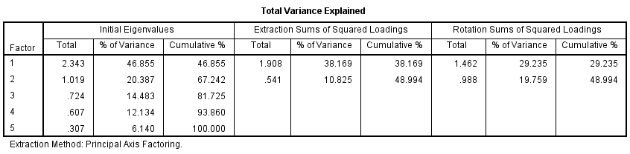
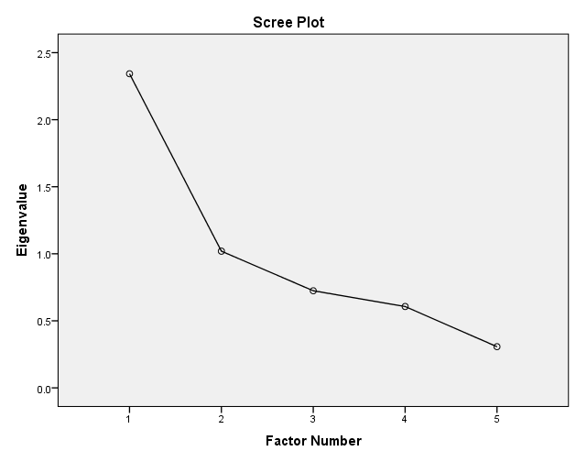 |  | 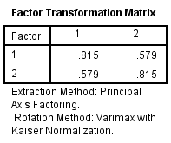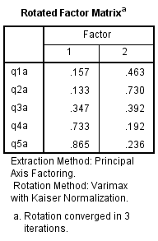
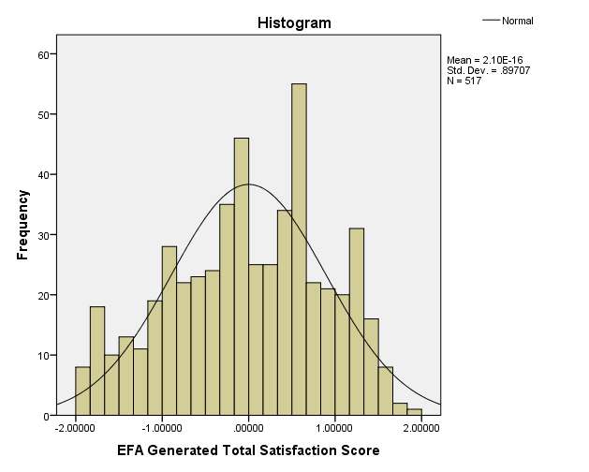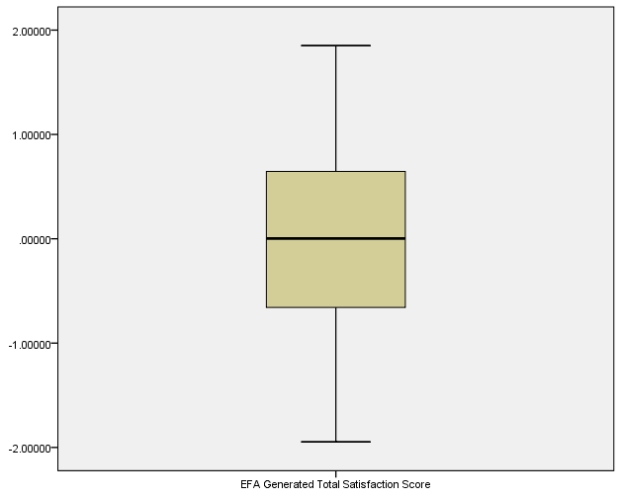 |  | 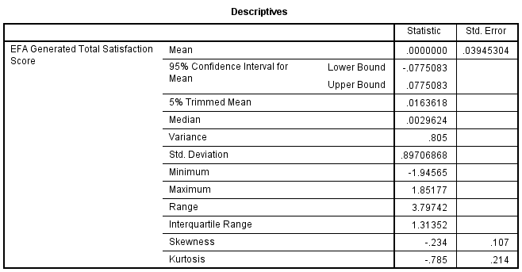

The dataset used in this exam paper is adapted from one included in J. Pallant, SPSS Survival Manual, 6th Edition, Allen and Unwin

